Numbers
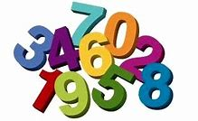

Count the numbers

1 2 3 4 5 6
7 8 9 10 11 12 13 14 15 16 17 18 19 20

Have a look around your house
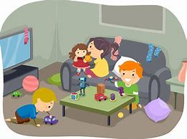
How many beds do you have?
How many tv do you have?
Have many microwaves do you have?
Have many drink glasses do you have?
Have many doors do you have?
Have many toilets do you have?
Have many clocks do you have?
How many kettles do you have?

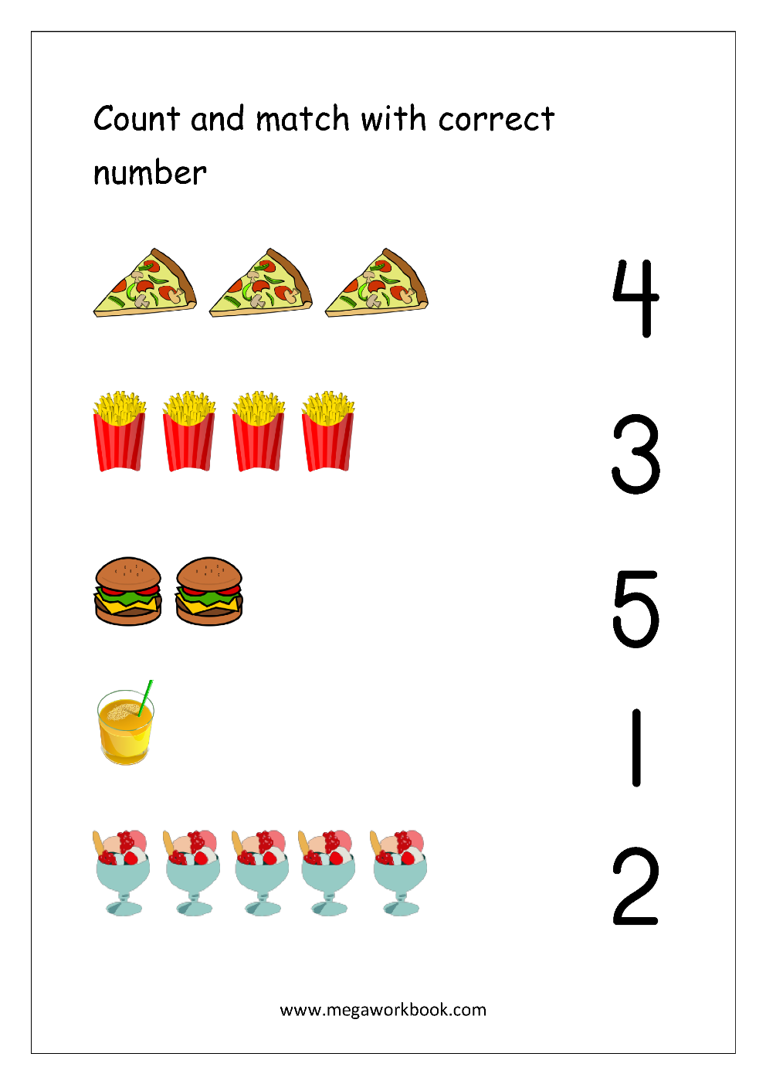
Name _______ Date ________
Number 1 -10
Match the same numbers

0 5
3 2
5 0
2 4
4 3
1 6
8 10
6 1
7 9
10 8
9 7
Have a look in the kitchen
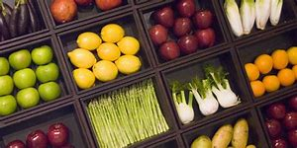
And see if you have any of the items below:
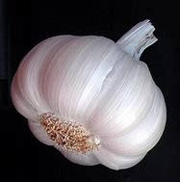
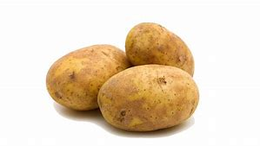
Potatoes Garlic

How many did you find? How many did you find?

Onions Baked Beans (tin)
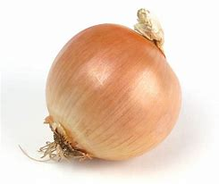
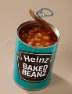
How many did you find? How many did you find?

Eggs Tomatoes
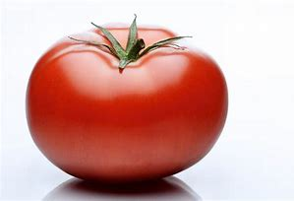
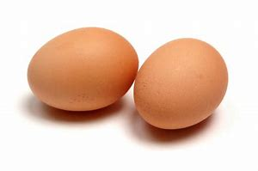
How many did you find? How many did you find?

Practise writing your numbers

1_______________________________

2_______________________________

3_______________________________

4_______________________________

5_______________________________

6_______________________________

7_______________________________

8_______________________________
9_______________________________

10______________________________

