Week 2- Extra activities for children to do with their families

- Family Tree
Create your family tree. Ask your family about your ancestors and create your tree. You could choose to set it out like this.
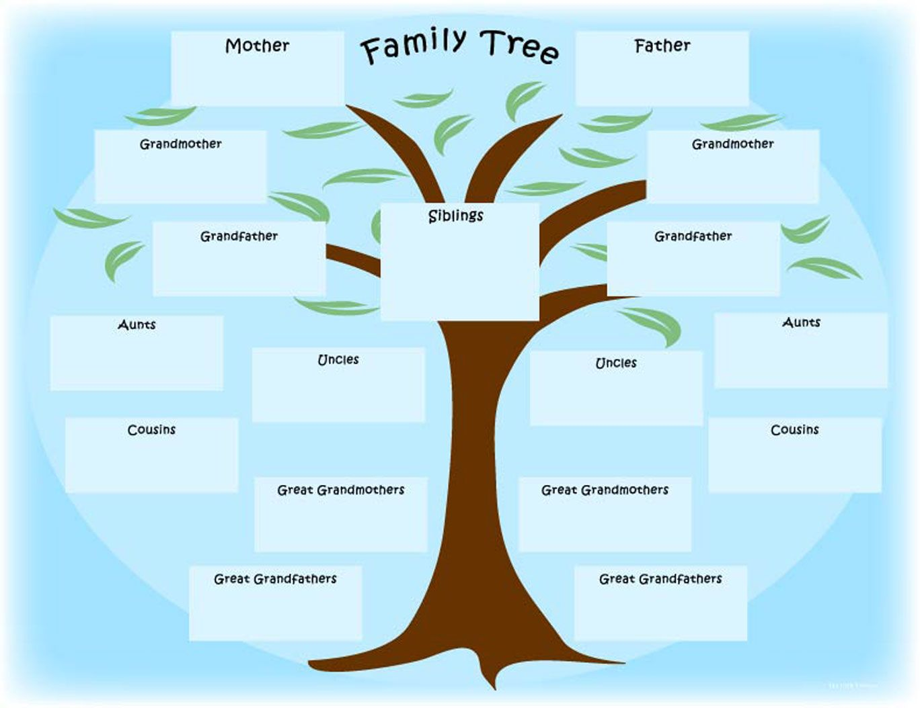
- Observational Drawing
Sit outside in your garden or at a window. Draw what you can see from what you observe around you. You could choose to lie down and look at the sky and draw what you see above you. Decide what media (coloured pencils, chalk, felt tips) you want to use to colour in your drawing and send me a picture of your final masterpiece to your teachers’ email. Make sure you write your name on it.

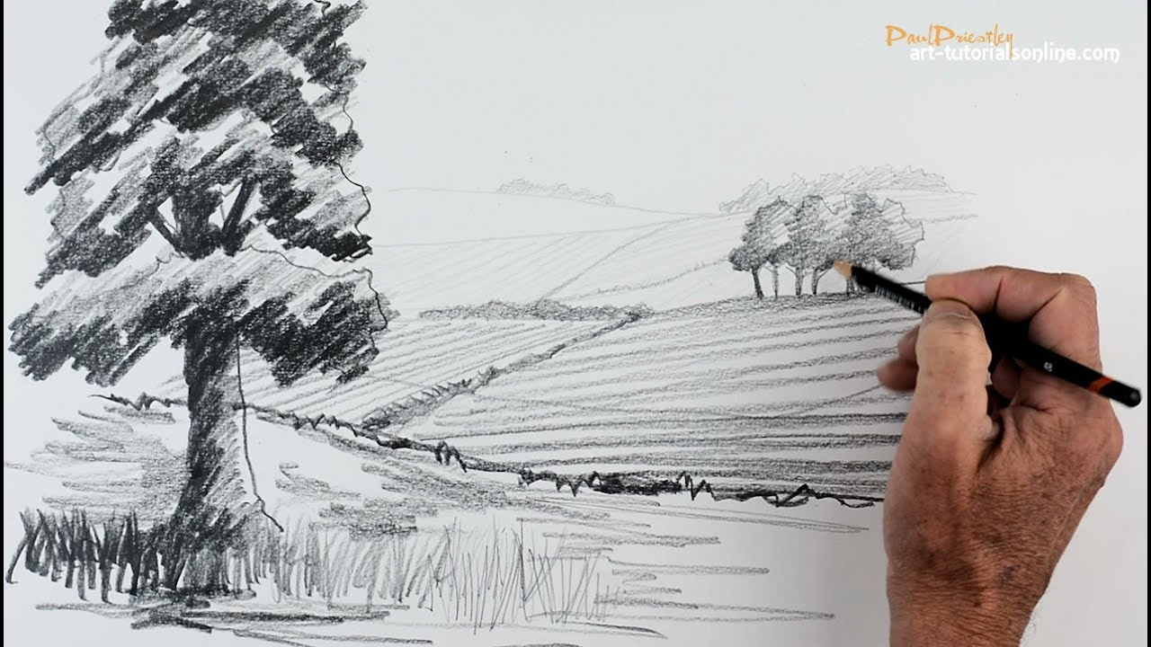

3.Learn how to cook! Cross curricular links, PSHE, Computer science (strands covered Algorithm/instructions, Digital literacy,)
Try to learn how to cook. You might be allowed to cook a meal for someone at home or it might be that you learn to cook one type of food e.g. a pasta dish or a breakfast dish. email me pictures/videos of you making the food. Write out the recipe. Get the people who eat your food to rate it and write comments and send these to your teacher by email. I will also comment on your food based on presentation and how appetising it looks! Have fun cooking but remember to ask an adult first and to stay safe in the kitchen.

