Wb. 23.03.20

Tuesday 24th March 2020 – Grammar – Parenthesis/Brackets

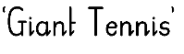
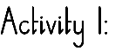

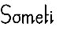
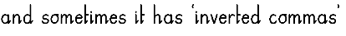
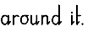
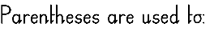
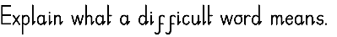
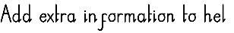
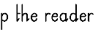
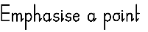
–

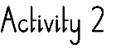

Please practice your spellings by using them correctly in sentences to have a better understanding of their meaning. Write your sentences in your books.

Spellings:
conscious, controversy, convenience correspond, criticise, critic, curious, debrief, deceit, deliberate
Wednesday 25th March 2020 – Writing – Narrative poetry
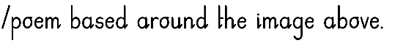
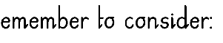
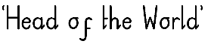
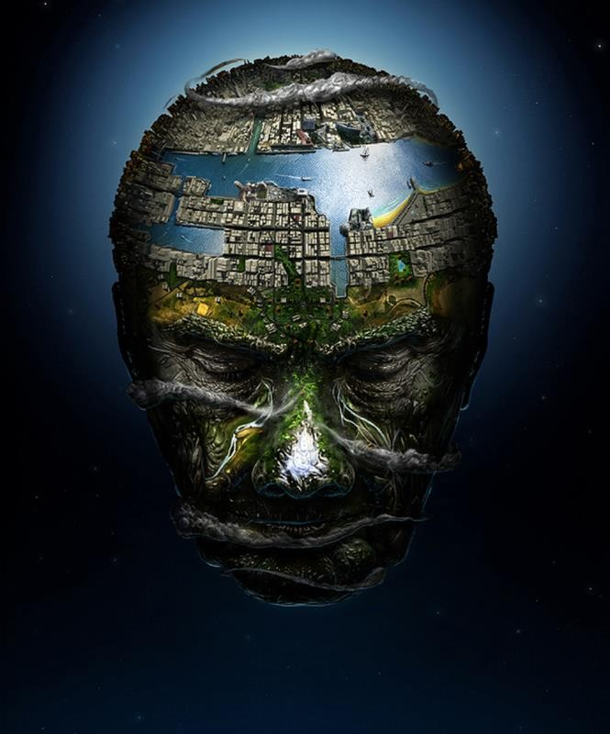
–

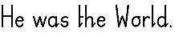
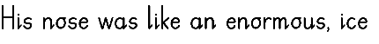
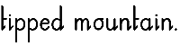
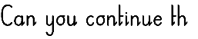
Thursday 26th March 2020 – Reading - Book Review

The epic poem!

Please write a review on this novel inspired by the historical epic poem that we have recently read.
Please make sure you include:

- A brief summary of the story

- Think about the events and characters throughout the story

- Share your thoughts and feelings about the story - some of the high points in the story (events or parts that made it enjoyable). Were there any setbacks (events that may have not been as enjoyable!)?

- How would you rate this novel overall?

*Please don’t forget to start off by telling us the name title and author of this book!

Friday 27th March 2020 – Reading Comprehension




