**Early Years Islamic Studies Weekly Plan**

**w/c 30th March**

**Daily Quran, duahs and qaida recitation 9.30 - 9.45am**

**- Read Waking up dua together with actions and meaning**

*"All praise is for Allah who woke us up after going to sleep"*

**- What is the name of the first surah in the Quran?**

Model language: “The first surah in the Quran is Surah Fatiha and we recite it in our prayers”. Then Recite Surah Fatiha together.

**- Recite the 4 Quls**: Currently memorising the fourth Qul: Sural Al kafiroon on ayah no 4.

Nursery children should all know Surah Fatiha and Ikhlas , Surah An-nas and Falq.

Reception children are at different levels so please practice all surahs memorised so far and proceed with the next surah for 10 min.

**Jummah**

- Practice Surah Kahf memorisation. Depending on where your child is currently at. Most children have memorised 4 ayahs.

- Plant Jannah trees by doing dhikr of Subhan Allah, Alhamdulillah, Allahu Akbar, Laillaha illalallah, Astaghfirullah. We plant 5 Jannah trees by saying the dhikr 11 times. Your child will know how to plant them. They make themselves like small round seeds in the ground and then grow by using the 'one potato, two potato' action to make themselves blossom into trees by standing tall.

- Parents to read Durood-e-Ibrahim with your child. Parents to say it word by word or line by line and then children can repeat it after you. Make it a habit every Jummah

- Prophet Stories - See Friday section on the last page.

**Things to do during the day as reminders:**

**- Toilet Run** - recite duahs. We do toilet run at 10am 11am and 2pm. Please recite duahs before going in and recite Gufranaka when leaving toilet.

**- Lunch Duahs** Recite eating dua together. After lunch recite the after eating dua together with actions. Practice Surah al kafiroon for 5min or the Surah your child is struggling with.

- Reminder to **Recite Sleeping Duah** before bed with actions *"Oh Allah with your name I go to sleep and wake up"* (This is a child friendly interpretation so they can understand the meaning easily)

**Islamic Studies**

Every week we will send you a different topic to discuss with your child. See attached activity sheets to read and colour each day in the following order.

This week's topic is **Tasmiyah / Bismillah**

**Bismillah-ir-Rahman-ir-Rahim**

In the name of Allah, The most merciful, The most kind

If we do not start anything in the name of Allah, it will be incomplete...

**Monday -**

- Teach/Ask children what Bismillah means (see attached Everyday Dua Resource)

- When do we say Bismillah?

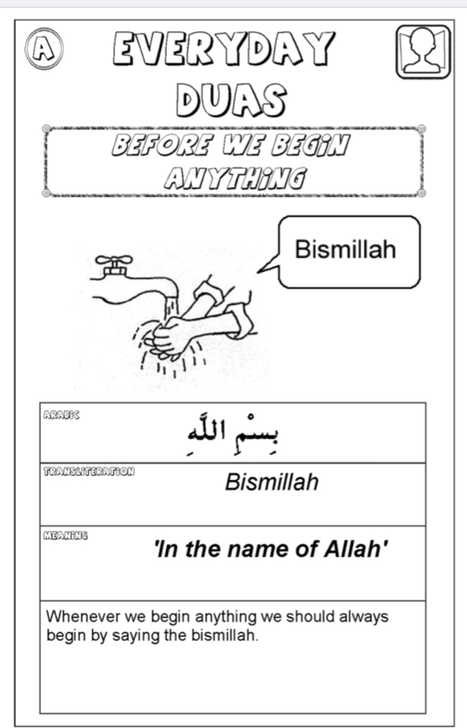

**Say B, B, Bismillah**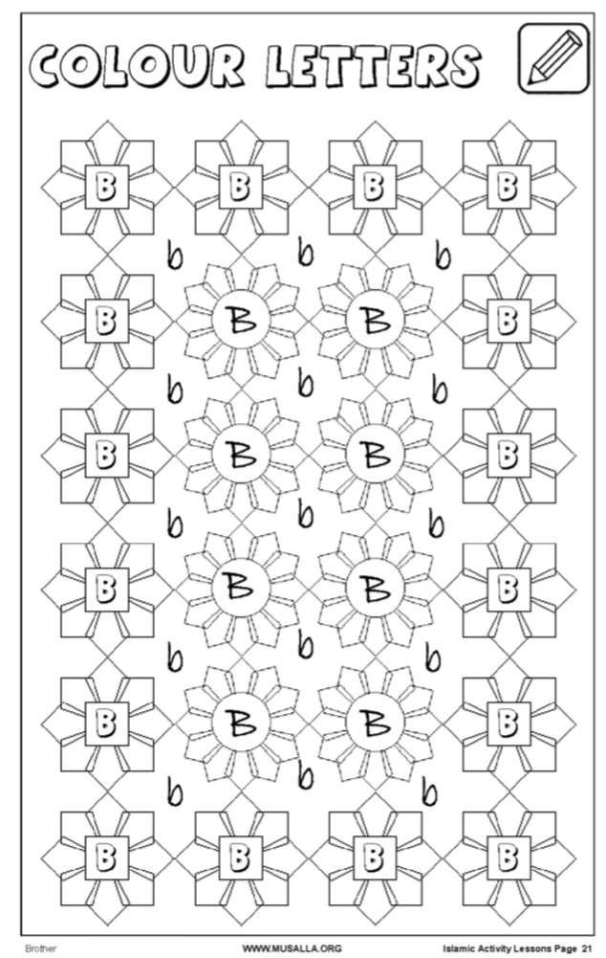

# Tuesday - Watch YouTube nasheed BISMILLAH ALHAMDULILLAH

<https://www.youtube.com/watch?v=MLnmhgmHcmE>

- Talk about the different things you can do by saying Bismillah before doing them.

- Get your child into the habit of saying Bismillah before doing anything. For example eating, dressing, brushing teeth, doing school work, playing with toys.

# Wednesday - Watch YouTube nasheed Bismillah Song

<https://www.youtube.com/watch?v=jdvOv3SyIts>

- Ask your child to think of different things they can do and say Bismillah before doing them. What letter does Bismillah begin with?

# Thursday - Watch YouTube nasheed Kids nasheed- BISMILLAH

<https://www.youtube.com/watch?v=-SQJ8UjgGoU>

**Friday / Jummah**

**Prophet Story time -** Listen to the story of Adam AS Part 1 & 2 on YouTube

Ask your children questions along the way

<https://www.youtube.com/watch?v=d-G56Gqdgf8&list=PLUpqHCJMOGtOXW6ycO6ZsIPMWMWHzmPC0>

What are angels made out of? Light / Noor

What do angels do? Worship Allah day and night

What are Jinns made out of? Smokeless Fire

What was the name of the first man Allah swt created? Adam AS

Did Shaytan / Iblis listen to Allah? No What he did not do? Shaytan did not bow down to Adam AS because he was jealous and thought he was better than Adam AS.

<https://www.youtube.com/watch?v=Hn1_P94Xby4&list=PLUpqHCJMOGtOXW6ycO6ZsIPMWMWHzmPC0&index=2>

What did Allah tell Adam and Hawa not to do? Not to eat from the tree

What did shaytan make Adam and Hawa do? Tricked them by telling them to eat from the tree

What is a Prophet? Adam was the first Prophet and a Prophet teaches people to listen to Allah SWT.